# CS 340 README

## About the Project/Project Title

## Austin Sonka is a company that trains cats and dogs for search and rescue operations. We have a program to identify and categorize animals for this mission. We provide functionality and interaction between servers and clients.

## Motivation

We saw traditional ways of organizing these search and rescues mission and saw there was a lot of inefficiency that could be fixed to move things faster and get homes for these animals sooner.

## Function

This allows server, client, and middleware into stacks. It can be used to filter data through python.

## Tools

Python- a computer language used for the base of the code.

MongoDB- hand in hand with python can be a good tool for flex and stability for projects.

Jupyter Notebook- Supports many languages and cells.

**Roadmap of the project:**

Imported Austin animal center outcome data

Created an animal_shelter.py file that allowed us CRUD functions

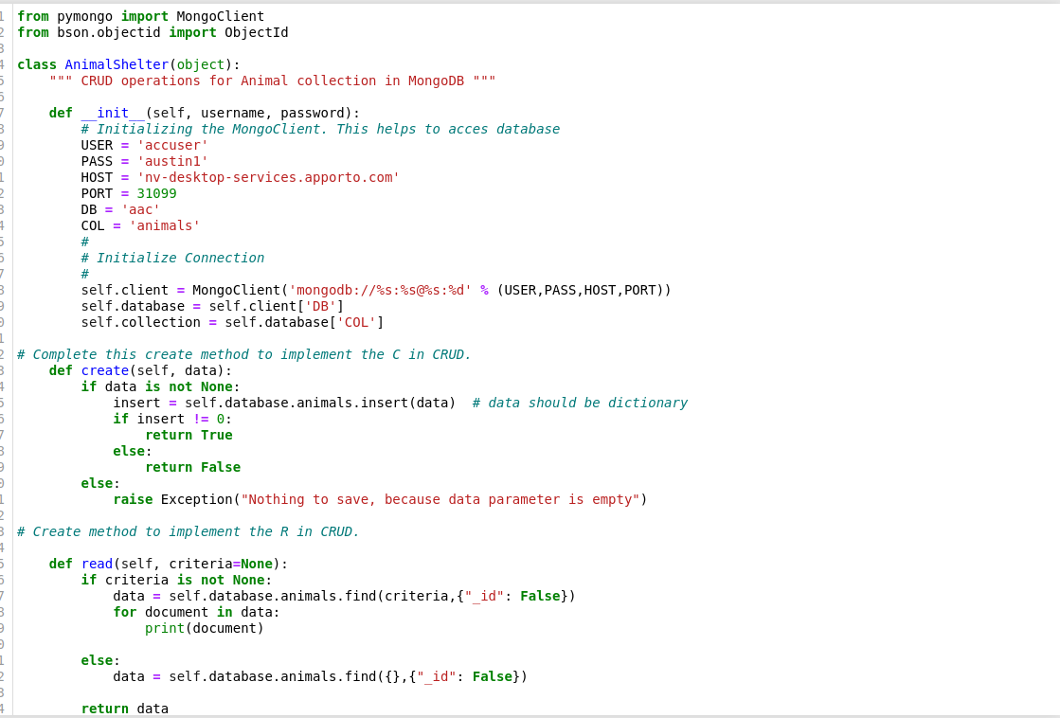

Screenshots of adding/updating/deleting an animal from system.

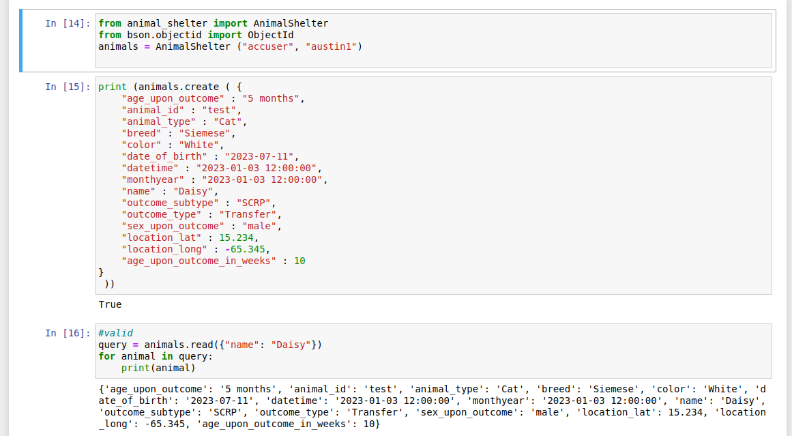

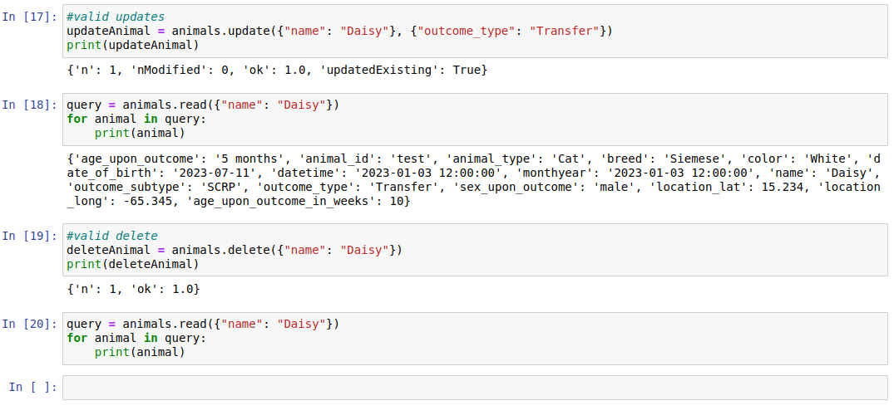

**Final Project Two:**

**When first running the file:**

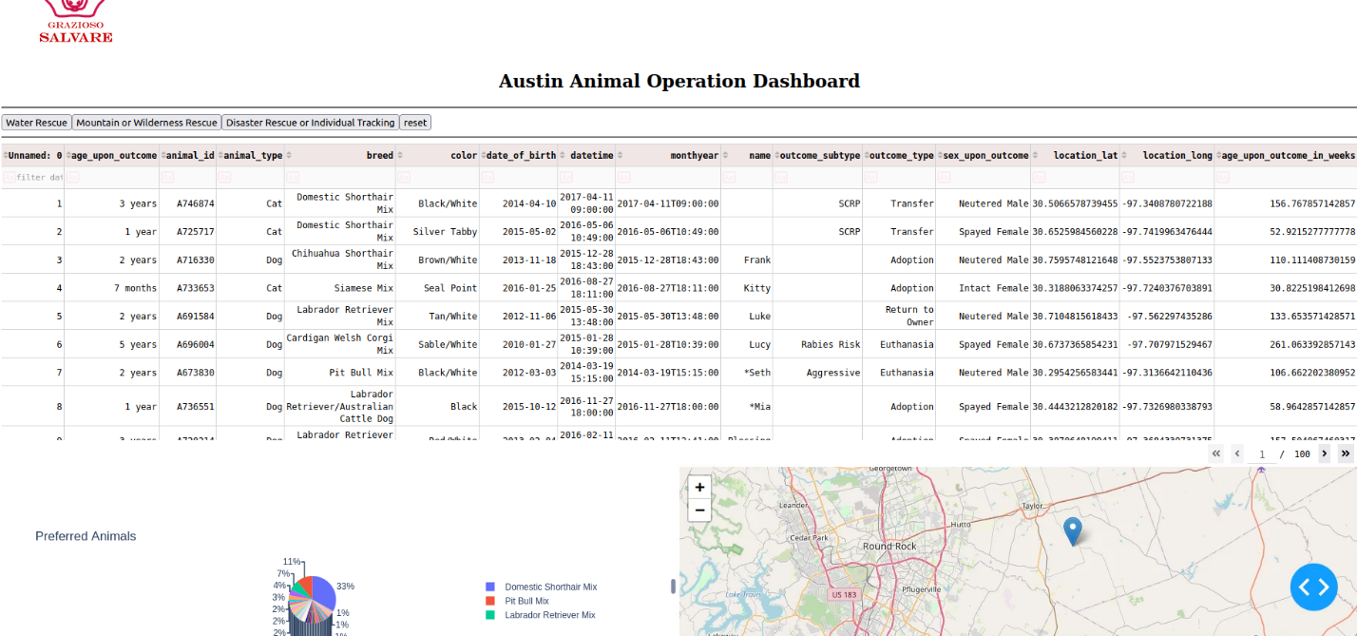

**Button 1:**

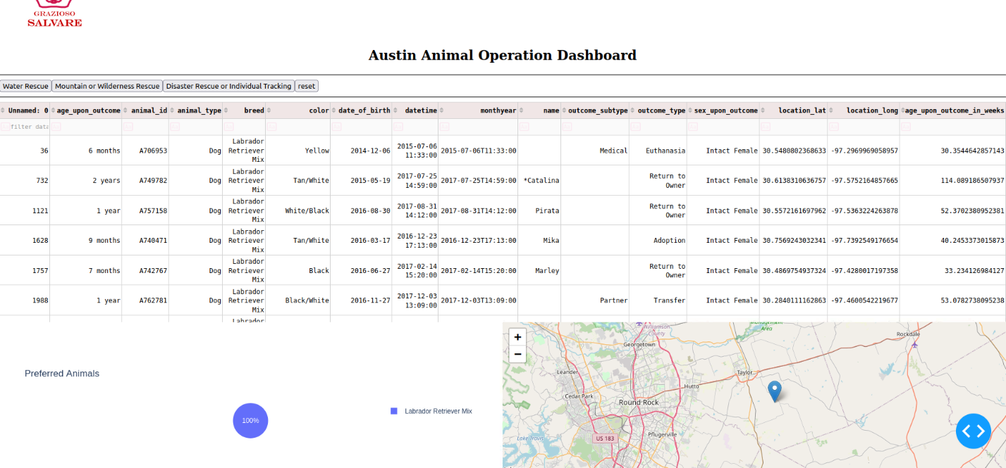

**Button 2:**

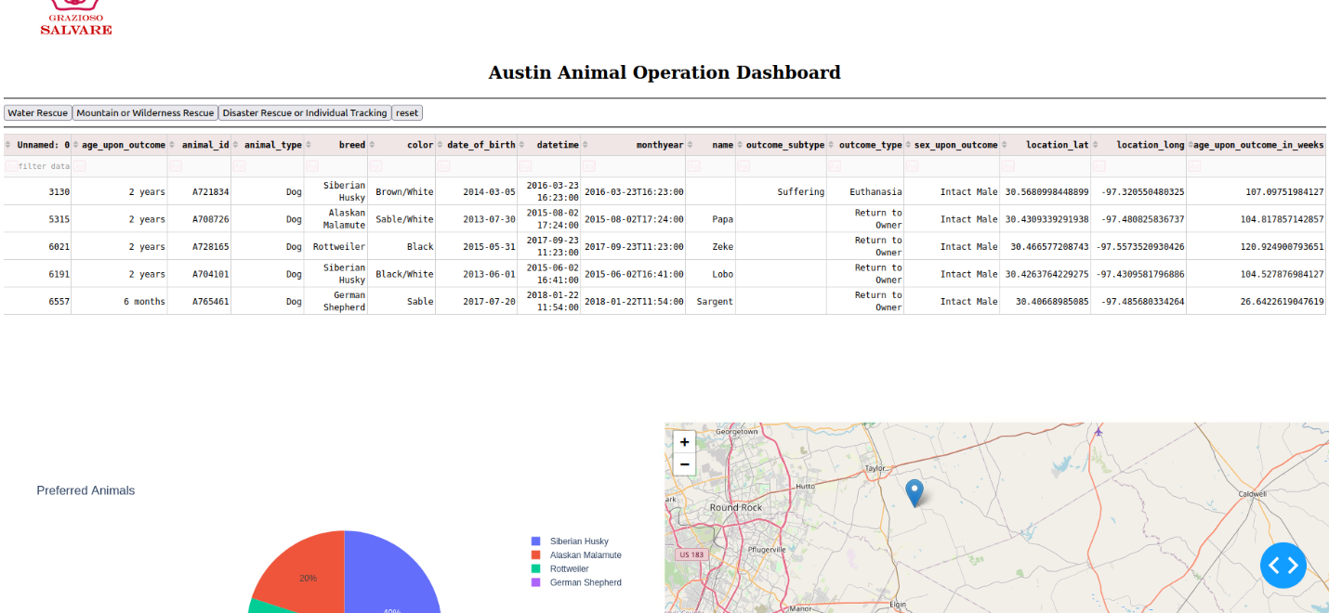

**Button 3:**

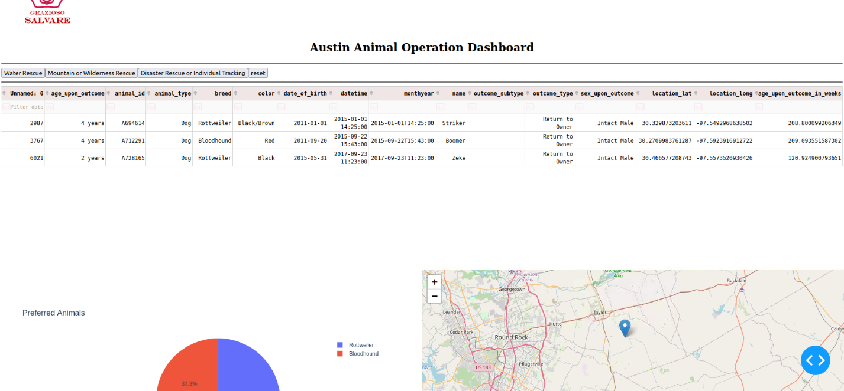

**With the reset button:**

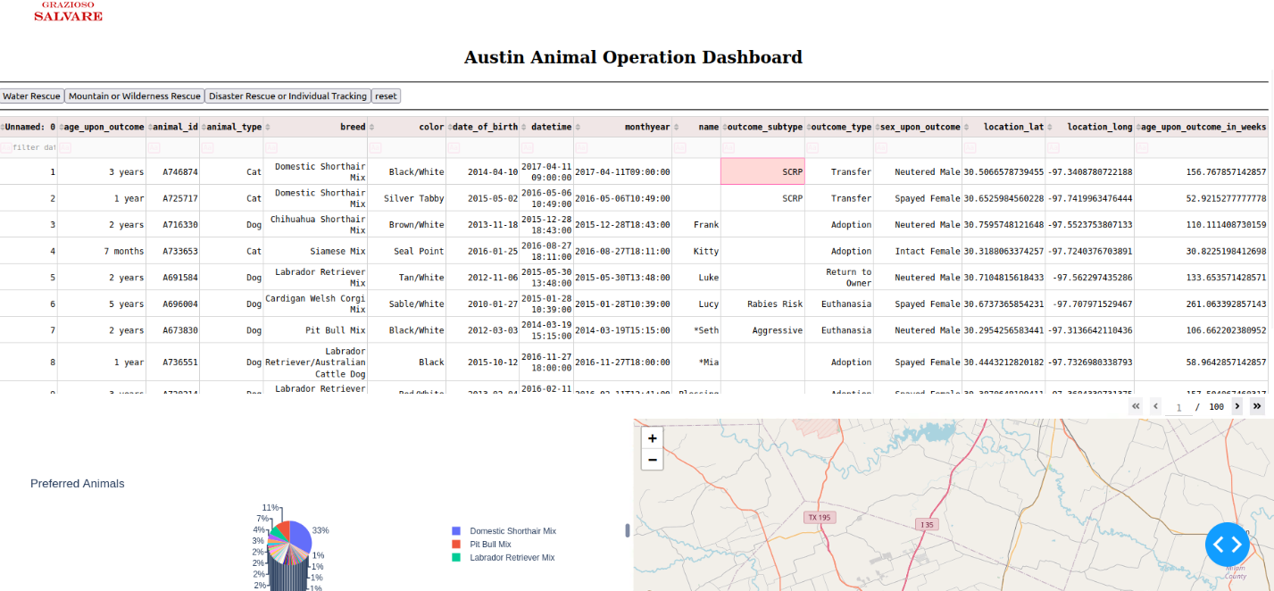

**Why MongoDB was used as the model component of the development, including what specific qualities or capabilities it provides for interfacing with Python.**

MongoDB is used to store and retrieve data

**Dash framework that provides the view and controller structure for the web application.**

The Dash framework provides the view and controller structure in the code by defining the dashboard layout and specifying the callback functions. In the dashboard layout, HTML elements and Dash components are used to create the user interface (view) of the web application. The html.Div, html.Img, html.H2, dash_table.DataTable, and dcc.Graph components are used to create different sections of the dashboard, including the logo, title, data table, pie chart, and map.

The callback functions (update_dashboard, update_graphs, and update_map) serve as the controller, handling user interactions and updating the view based on those interactions. These callback functions are triggered by specific inputs, such as button clicks and data selections, and they update specific components in response, such as the data table, pie chart, and map.

**Be sure to include links to any resources or software applications that were accessed or used.**

* MongoDB: <https://www.mongodb.com/>
* PyMongo (Python driver for MongoDB): <https://pymongo.readthedocs.io/>
* Dash: <https://dash.plotly.com/>
* Plotly: <https://plotly.com/python/>
* Files given in class

**Steps taken to complete the project:**

A number of steps were being taken in completing the project as every module increased in difficulty, It was sort of like a puzzle and each module we added a piece of the final puzzle.

## Roadmap/Features (Optional)

Some challenges that may come to light while using the program are wrong username or password. Also, to make sure they exist in the first place. Port or host information could be off by user use. Most of all the challenges really was trial and error for hours, sometimes it would be indentation, other times it was the py file or even missed spelled words. Lot of these problems got solved when rereading the code and seeing what error we were getting when running the code.

## Contact

Austin Sonka

Austin.sonka@snhu.edu